**Project Planning Phase**

**Project Planning Template (Product Backlog, Sprint Planning, Stories, Story points)**

|  |  |
| --- | --- |
| Date | 02 November 2022 |
| Team ID | PNT2022TMID15069 |
| Project Name | Personal Assistance for Seniors Who Are Self-Reliant |
| Maximum Marks | 8 Marks |

**Product Backlog, Sprint Schedule, and Estimation (4 Marks)**

|  |  |  |  |  |  |  |
| --- | --- | --- | --- | --- | --- | --- |
| Sprint | Functional Requiremen t (Epic) | User Story Number | User Story / Task | Story Points | Priority | Team Mem |
| Sprint-1 | Hardware or Simulation Software | USN-1 | Using Wokwi , Connect ESP-32 with UltraSonic Sensor with Python script | 2 | High | Shaik Kamiloon, Subhashri K S , Varshini Sagarikaa M S, Sofia B |
| Sprint-2 | Cloud Software | USN-2 | Create Device in the IBM Watson IOT Platform and link it to Wokwi | 2 | High | Shaik Kamiloon, Subhashri K S , Varshini Sagarikaa, M S, Sofia B |
| Sprint-3 | Website | USN-3 | Create a web application | 2 | High | Shaik Kamiloon, Subhashri K S , Varshini Sagarikaa M S, Sofia B |
| Sprint-4 | linking | USN-4 | Link Device, IBM cloud and the developed appllication | 2 | High | Shaik Kamiloon, Subhashri K S, Varshini Sagarikaa,M S, Sofia B |

**Velocity:**

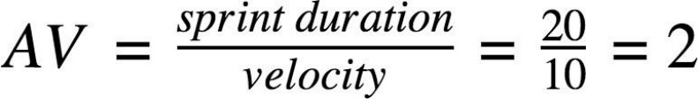

Imagine we have a 10-day sprint duration, and the velocity of the team is 20 (points per sprint). Let’s calculate the team’s average velocity (AV) per iteration unit (story points per day).